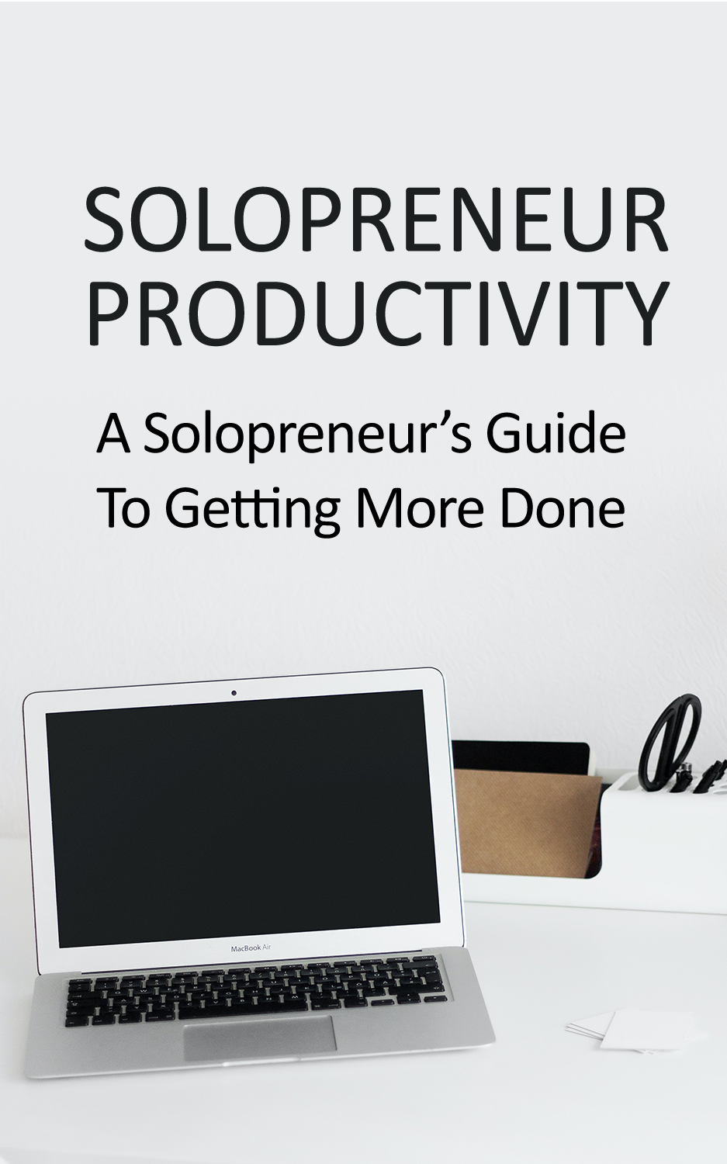

TOP RECOMMENDED GUIDE:

**Solopreneur Success: How Grow Your Business as a Solopreneur Faster and Smarter**

Find Out The Exact Steps And Techniques!



**>> Click Here To Get Your Copy <<**

# Introduction

As a solopreneur, no one is going to be telling you when you need to work. You will need to learn when to complete tasks and handle the management of your business yourself. Many solopreneurs love working by themselves, but it can be difficult to stay productive.

When you are more productive, your brand is going to make more conversions- leading to more funds. If you want to work more efficiently, be sure to read this brief article.

We are going to offer you plenty of tips to increase solopreneur productivity. Let’s begin.

# Manage Your Tasks

To start, you will want to make sure that you are always managing your tasks and errands. It will help if you know what tasks need completed soon and what ones you can put off. Plus, are you able to consolidate any errands or tasks together?

When you are grocery shopping, you probably make sure to pick up all your items that are in the same aisle at once. It does not make sense to walk across the store to grab eggs, then get the bread, then go back for milk. You are going to be using your time more efficiently if you can consolidate tasks.

You can do this by grouping your tasks and projects together. At the start of each day, take ten minutes or so to sit down and determine what needs to be finished. Then, group your tasks together where it makes sense. Maybe you can check your emails and brand social media at the same time, then get to work on creating content after.

When you group your tasks together, your mind does not have to shift its focus. This allows you to better stay in a strong workflow.

# Simplify Your Meetings

Do you dread meetings? Do they feel like a waste of time? Well, then they might be. You might want to make some changes.

If your meetings are long, pointless, and seem to never solve anything, you will want to do implement the following change:

* Keep them short, to the point, and as brief as possible.

Once you can do that, you will be on a much more productive path. It helps when your meetings are forced to be brief- only the most important subjects are brought up. You can start by having one goal in mind for each meeting. Once you have covered that goal, the meeting ends.

Shorter meetings are better for everyone involved. You can spend more time being productive on your work, without feeling drained after the meeting. As long as your meetings encourage open communication and not long discussion, the change will be present right away.

You can also keep your emails direct and to the point- phone or Zoom calls too!

# Follow the Three Minute Rule

This little rule is an excellent tool to get rid of nonessential tasks, so that you can get abc to the more important matters at hand. The rule states that you should only complete the task if you can do it in three minutes or less. This could be for anything during your workday.

Responding to emails, doing chores at home, organizing your files, or other tasks. If they are taking away from your work during your scheduled hours, then you will want to avoid anything that does not take less than three minutes once you get to work.

It is best to complete these small tasks earlier in the day, before you start your solopreneur schedule. That way, they are done quickly and will not distract you later on.

# Pay Attention to Your Energy

Our energy levels throughout the day shift. We are not constantly productive or constantly relaxed. We tend to each have our own periods of productivity- some hours the work comes naturally. Others, you might feel like you have to force yourself to complete a project.

Start paying attention to your energy levels throughout the day. This will let you see some patterns over time. Then, you will be able to work during the times when you are most productive and relax during the times your body wants you to rest.

There are many benefits to this. However, the most important is that you are never going to have to force yourself to work! When working during your most productive times, you will feel less stress and notice the quality of your work improving too.

If you want to try tracking your energy, you can record it in a notebook or in an app. By simply making note of your energy levels, you can become an exceptional solopreneur. Checking in with yourself often will help you to stay grounded as well.

# Learn to Stop Procrastinating

Procrastination is going to ruin your workflow and have a significant impact on your business ventures. As a solopreneur, no one is telling you when to start working- you need to be disciplined enough to start on your own.

One way to stop wasting your time like this, is the “Give It Ten” rule. This is a simple little rule that allows you to work, even if you might not feel like it. All you have to do is sit down at your workstation and say “I am going to give it 10 minutes”, this can make a world of difference!

Then, work for 10 minutes straight and check in with yourself. Often, starting the task is much harder than finishing. When you “Give It Ten” you will notice that you want to continue working, so that the task is not left unfinished. From there, it is much easier to put more time and effort into the task.

# Keep a Schedule

As a solopreneur, you will need to be responsible for your own schedule. While this does mean that you can work when you want, you need to keep track of it. What if you miss a deadline for a client or forget to complete a project?

You will need to follow a consistent schedule and keep a planner. It can be something simple, like a blank notebook, or even a calendar. Whatever you use, you need to be sure you write your schedule in it.

Your schedule can also grow and change as you and your business does. If you notice that you are more productive in the evening- then be sure to adjust your schedule! You will get more done and have a record of everything that you need to do.

When we have our days planned, it makes it much easier to be productive. Some people will even write tiny tasks down such as showing, taking out the trash, or making a social media post. That way, they know that they have everything they need planned for and ready to go.

Plus, scheduling will help you avoid distractions and keep your business priorities in focus.

# Learn to Delegate

Just because you are a solopreneur does not mean that you need to work completely alone. You might consider working with a freelancer to create content or hire a virtual assistant to help you plan your days. No matter what, it is important that solopreneurs learn to delegate their tasks.

Outsource projects or small tasks that someone else can do for you. Your virtual assistant might help you with communication and scheduling, which would take your time away from more important matters if you were to do it yourself.

Delegating tasks will allow you to spend time working on your goals. That being said, you do not want to delegate work, then relax. You would be losing the time that you just got back- time that you would still not be putting into your solopreneur business! .

# Get Rid of Distractions

We are all guilty of checking our phones at work. However, as a solopreneur without a boss looking over their shoulder, you might feel like you can do this more often. A solopreneur needs to be dedicated and learn to manage their time to be successful- this means getting rid of distractions.

You can mute your phone and put it out of sight. If that does not work, you can use apps that will lock your phone for a certain amount of time. There are plenty of options that you can find online.

Plus, you will want to get rid of other distractions. You can set up a workstation to start. When you sit down at your desk, you will want to enter “solopreneur mode”- get focused and only work on your business for a set amount of time.

One method that has greatly helped many other solopreneurs is the Pomodoro Technique.

# Pomodoro Technique

The Pomodoro Technique was designed for students originally, but anyone can use it to get work done. There are a few different versions, but they boil down to the following:

* Work for 25 minutes straight, take a five minute break
* Work for 50 minutes straight, take a ten minute break

All you need to do is set a timer, then work for that amount of time. When the timer goes off, take a short break- just relax, check your phone, or doodle. By not thinking about the project for a few minutes, you are resetting your brain. This will help you be more productive when you start another timed work session.

This technique has worked for plenty of solopreneurs, so be sure to give it a try! You will be surprised at how much work you can complete when you give it your utmost focus for 25 minutes.

# Start a Morning Routine

A morning routine will help you out a lot. When you are consistently doing the same activities each morning, then going to work, your brain will recognize the pattern. Each time you complete the routine, it becomes easier.

As a basic routine, you might want to consider the following steps:

1. 7 AM: Wake up and drink water
2. 7:20 AM to 7:50 AM: Exercise
3. 7:50 AM to 8:10 AM: Shower
4. 8:10 AM to 9:00 AM: Make and eat breakfast, wash dishes
5. Start work at 9 AM; work until 5 PM

Of course, everyone is productive at different times. If you are more of a night owl, you will want to adjust your routine accordingly.

Still, many solopreneurs can benefit from having a consistent routine. This will allow you to start up your workflow in the morning, preparing you for the rest of your day. It is also essential that you take breaks and stretch when you are starting to run out of energy.

# Taking Breaks

During your work day, you will want to take breaks here and there. They do not need to be long; you just need time to get up, walk around or stretch, and drink some water. This will assist you in staying alert and help you focus on completing your projects.

If you skip breaks, you will start to feel drained. It is much better to put breaks into your schedule and end later in the day, than to skip them and end earlier. You will feel much better and the consistency of your work will be much higher as well.

# Conclusion

As a new solopreneur, you will need to spend a lot of time working on your schedule. You want to create a routine that suits your needs and allows you to feel energized during the day. That way, you can be productive without feeling like you are fighting with yourself constantly.

TOP RECOMMENDED GUIDE:

**Solopreneur Success: How Grow Your Business as a Solopreneur Faster and Smarter**

Find Out The Exact Steps And Techniques!



**>> Click Here To Get Your Copy <<**